**CLQB Average Time Spent Per Page – BOP**

**Description:** The graph illustrates the average time spent by users on each page within the Business Owners Policy (BOP) workflow. The data displayed (default loading for the average time spent page) corresponds to the 90th percentile of user engagement over the last 24 hours, and shows the amount of time users spend on each of the pages.

For instance,

* Users have spent an average of 1.01 seconds on Default page, 6.13 seconds on State Specific Info page, and so on.
* The unusually long average time spent for page(s) (Blankets) is highlighted in red.

The ability to switch between percentiles (90th, 50th, 10th, and All) and time periods offers deeper insights into user behavior trends with respect to the engagement variability on different pages.

**Graph:**

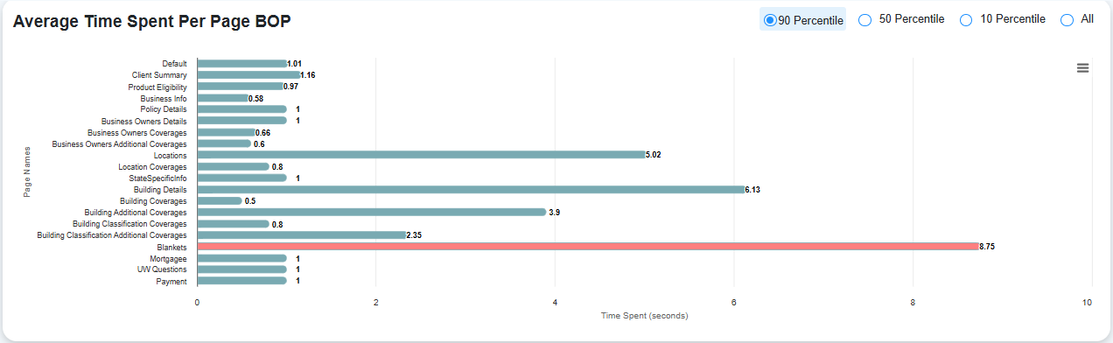

The x-axis shows the average time spent (in seconds) and the y-axis shows the page names.